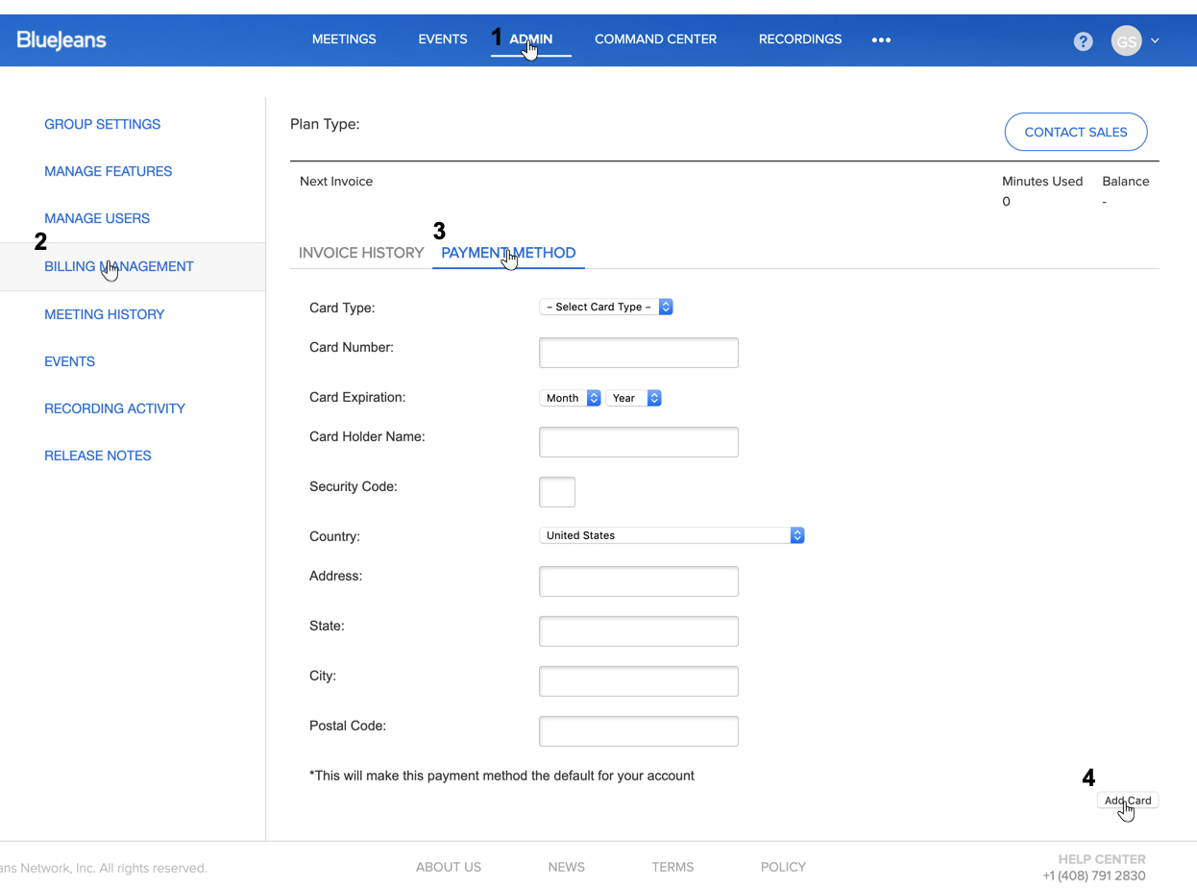

The Enterprise Group Administrator can log into their account and enter/edit the credit card on file:

1. Click the Admin tab at top
2. Click Billing Management
3. Click Payment Method and enter/edit your credit card details
4. Click Add Card

Once you’ve added a credit card, BlueJeans will automatically charge your credit card against the open invoice on your account. You do not have to log in and apply the payment yourself.

Note: if you are not the Admin of the account but would like to provide the credit card details for payment, please reach out to us at AR@bluejeans.com. We will send you a link that will allow you to provide the details to us.

